**Sprint Planning:** GotoGro-MRM

**Team Details**

|  |  |
| --- | --- |
| **Team Name:** | MSP 14 |
| **Tutorial:** | Tue 2:30 ATC325 |
| **Tutor:** | Dr Kaberi Naznin |

|  |  |
| --- | --- |
| **Members:** | |
| Dylan Jarvis | 102093138 |
| Rabya Tayal | 103144215 |
| Simon Tran | 103602807 |
| Thomas Babicka | 103059885 |
| Cody Cronin-Sporys | 103610020 |
| Nicholas Dyt | 101624265 |

**Sprint Management**

With the first sprint about to start the necessary productivity tools have been set up to keep the team on track and aiming to complete their tasks. The screenshots below were taken at the start of sprint 1.

**Day 0 Trello Task Board**

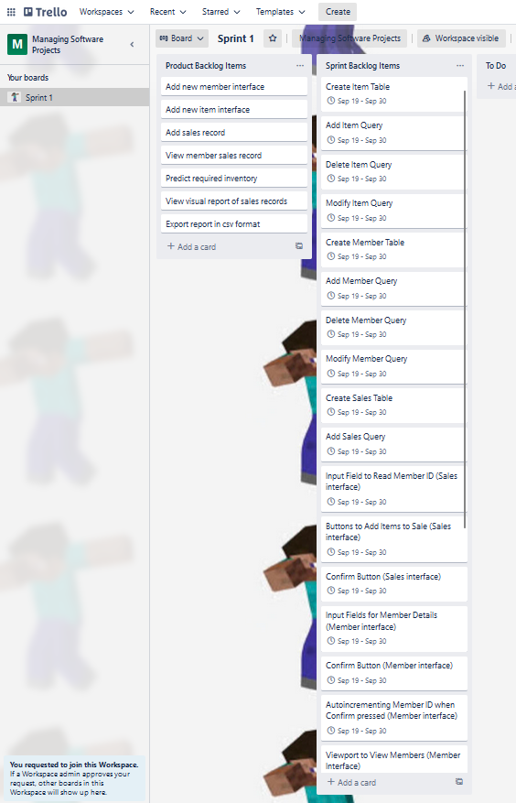

The Trello board captures the list of tasks discussed and justified in task 08P. They were given bounded dates for completion which will be used by the burndown chart. Currently they all have the same completion date, however they are listed in order of importance. In future team meetings we may opt to put stricter dates especially on the earlier items.

**Day 0 Burndown Chart**

Of the 27 items created for this sprint the ideal burndown chart was created by Trello. It appears that the sprint is designed with a small break in the middle, this gives the team a chance to get ahead if we continue at a steady pace.

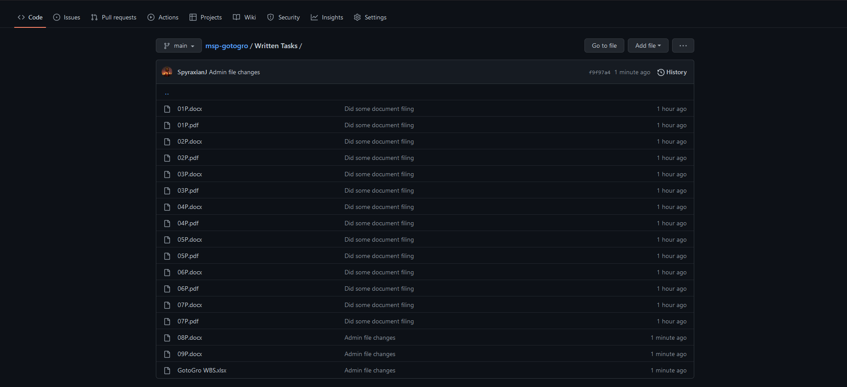**Day 0 Github Repo**

The Github repo has been set up, currently it only contains the previous written tasks. This way the team can also use Github as a resource for completing the group assessments.